SID VALLEY HELP

Report and Financial Statement
for the year ending 31 March 2026

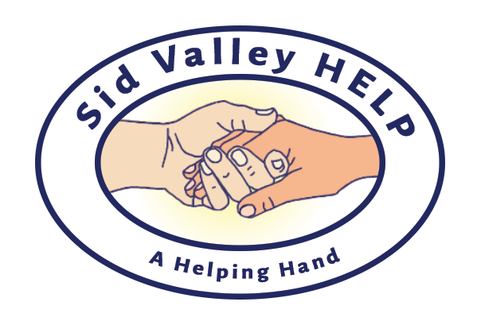

Registered Charity Number 1181458

SID VALLEY HELP

Year ending 31 March 2026

Contents Page

Reference and Administrative Details 2

Structure, Governance and Management 3

Report of the Trustees 3

Financial Statement 5

Accounts 7

Independent Examiner's Report 8

SID VALLEY HELP

Year ending 31 March 2026

The Trustees are pleased to submit their report together with the financial statements of Sid Valley Help for the year ending 31 March 2026 which have been prepared in accordance with the charity’s governing document and Charities SORP (FRS102).

Reference and Administrative Details

Charity Number: 1181458

Charity Registration: 7 January 2019

Organisation Type: Charitable Incorporated Organisation

Charity Address: Cosmopolitan House
Old Fore Street
Sidmouth
Devon EX10 8LS

Email: info@sidvalleyhelp.org.uk
Website: sidvalleyhelp.org.uk
Phone: 01395 892 011

Independent Examiner: Robert Underhill
Sidmouth, Devon

Bankers: Charities Aid Foundation Bank
25 Kings Hill Avenue, West Malling, ME19 4TA

Trustees: Jan Campbell Young (elected 28 November 2023)
Diane Fuller (retired 12 November 2025) Keith Gillanders, Chair (re-elected 19 November 2024) Andrew Hardy (re-elected 12 November 2025)
Judith Jeeves (elected 12 November 2025) Charles King (elected 12 November 2025)
Hazel Nelson, Treasurer (elected 19 November 2024)
Ronald Peppin (re-elected 12 November 2025)

SID VALLEY HELP

Year ending 31st March 2026

Structure, Governance and Management

Governing Document
Sid Valley Help is registered as a charity with the Charity Commission, number 1181458. It is a Charitable Incorporated Organisation (CIO) and is governed by its Constitution Document.

Appointment of Trustees
All of the founding Trustees were elected by the members at the AGM on the 11th September 2019 and the Chair of the Trustees was elected by the Trustees. Other Trustees were elected at subsequent AGMs or co-opted. One third of the Trustees retire by rotation each year and are eligible to stand for re-election.

Charitable Objectives
To relieve sickness and promote and protect the good mental and physical health of persons in the Sid Valley and surrounding areas, in particular but not exclusively by:
- Signposting to other health and care organisations and services;
- Befriending those suffering poor health or at risk of poor health; and
- Building capacity of, and encouraging health and care services and organisations to network to improve the provision of services and fill any gaps in provision.

Report of the Trustees

Sid Valley Help provides easy access to information for people who need help from health and care organisations and we enable health and social care professionals to identify non-statutory and voluntary sector services in the community to support clients, patients, carers and their families. We continue to work closely with local councils and other VCSE sector organisations to provide information and we offer direct support to some of the most vulnerable members of our community.

We are very grateful for the dedication of over 25 volunteers who visit clients at home or help in delivering classes and events. They contribute hugely to the success of our charity.

We have also to thank the many people and organisations who have given us donations, including Sidmouth Parish Church and Primley Women’s Institute, and those who have awarded us grants, including the Sidmouth Town Council, the National Lottery Community Fund and the NHS Devon ICB Healthy Ageing Fund.

The following paragraphs describe progress under the headings of our charitable objectives:

- Signposting to other health and care organisations and services:
- We continued to maintain our website and a data base of organisations providing help to those in need of health and wellbeing support and we receive positive feedback about the ease of using our website where people in need can access information and make direct contact with organisations.
- We have an email and phone Helpline that answers about 20 enquiries a month. People are referred to appropriate organisations or helped directly by Sid Valley Help. We provided signposting and referrals on behalf of those unable to do so themselves.
- We have had representation in person and online at the weekly NHS Community Health and Social Care team where the support required by the most vulnerable members of the community is discussed.

- Befriending those suffering poor health or at risk of poor health
- All befriending provided by Sid Valley Help is offered face to face with occasional telephone calls as required. The demand for this service has continued at about 30 clients.
- Befriending volunteers who visit clients’ homes require careful recruitment, training, on-going support and monitoring. We employed a part time Volunteer Manager during the year.
- Our volunteers run monthly Young at Heart meetings for women over 50 and these have proved very successful in developing friendships.

- Building capacity and encouraging health and care services and organisations to improve the provision of services and fill gaps.
- We continued to provide a network for partner organisations and held three stakeholders' meetings to improve understanding about services in the area and to improve collaborative working and building capacity.
- We provided training for volunteers and partner organisations on safeguarding.
- We continued to provide Strength and Balance classes for those who have had falls or are at risk of falling.
- We provided IT advice and support from a the Info Hub on High Street
- We represent Sidmouth VCSE groups on the Eastern region Local Care Partnership VCSE reference group.
- Sid Valley Help has continued to provide governance and funding for the WHAT Steering group made up from statutory and voluntary organisations that have a key role in working with or supporting the mental health and wellbeing of children and young people. Members include Sidmouth College, Sidmouth Primary School, Young Devon, Action East Devon, Parental Minds, Sidmouth Town Council, and Sidmouth Coastal Community Hub. On the recommendation of WHAT we commissioned:
- One to one mentoring for young people in Sidmouth College from Action East Devon. Unfortunately, AED were unable to continue this service after the end of August 2025.
- A regular support hub in the Sid Valley for parents and carers struggling to support children with mental health issues. This was provided by Parental Minds.
Financial Statement

During the year the total income was £46,093 of which £27,898 was restricted.

The total expenditure was £30,064. However, because we use cash basis accounting this figure does not take into account £5,000 which was due in this year but will not be paid until 2026/7. If these invoices could have been paid in 2025/6 our expenditure would have been £35,064.

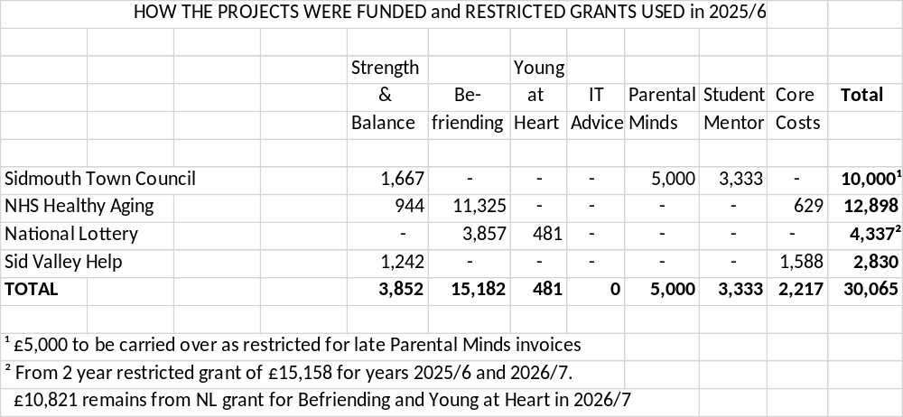

Income exceeded expenditure by £16,029 but, as noted above, if all the due invoices could have been paid in 2025/6 the excess income over expenditure would have been only £11,029.

This year, £21,283 of income was non-recurring: £12,898 came from a one-off grant (NHS ICB), £6,000 from a legacy and £2,385 from one-off donations by two organisations.

We go into 2026/7 with healthy assets of £51,629 or, more meaningfully, £46,629 if taking into account the £5,000 debt carried over from 2025/6. The Trustees are confident that the existing financial resources together with anticipated grants are sufficient to continue the current level of activities for the next twelve months. However, the Trustees are mindful of the need to pursue further grants and fund-raising activities in order to continue the activities of the charity into 2027-28 and beyond.

Statement of Trustees' Responsibilities

The Trustees are responsible for preparing the annual report and financial statement in accordance with applicable law and UK generally accepted accounting practice. The Trustees are responsible for keeping proper accounting records which disclose with reasonable accuracy the financial position of the charity and enable them to ensure that the financial statements comply with the Charities Act 2011. They are also responsible for safeguarding the assets of the charity and hence for taking reasonable steps for the prevention and detection of fraud and other irregularities.

Trustees acknowledge their responsibility for identifying, assessing and managing risk. A risk assessment has been carried out and is reviewed periodically. A standing item at each Management Meeting is to identify any new risks.

This report was approved by the Trustees on the 4th June 2026 and signed on their behalf by:

Keith W Gillanders

Chair of the Board of Trustees
Sid Valley Help
Accounts for the year ending 31st March 2026

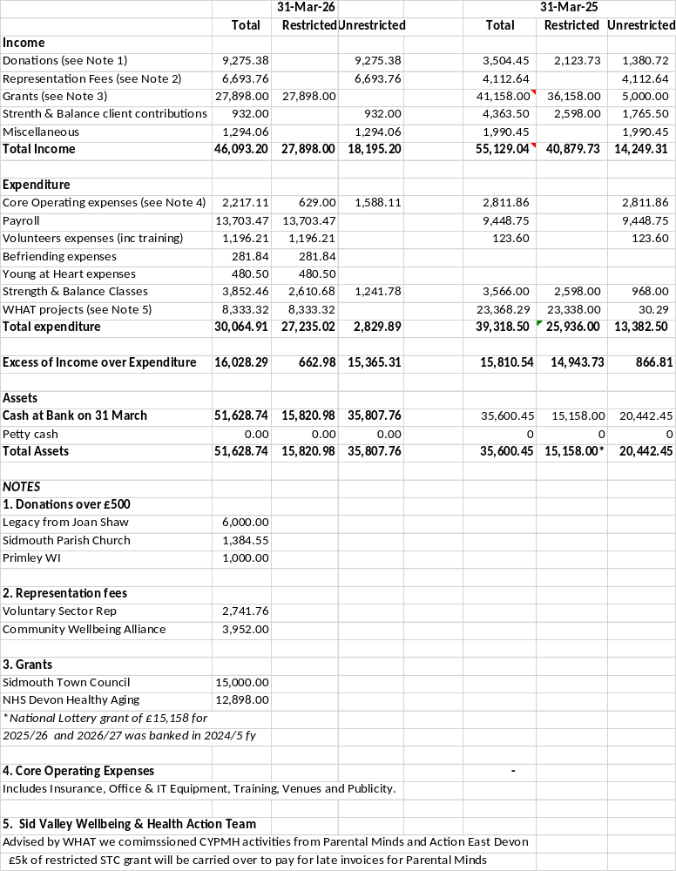

Keith W. Gillanders Hazel E. Nelson
Chair Treasurer
Independent Examiner’s certificate

